List of Tables

Table 1: Effects of sentinel presence and generalized environment on the proportion of time allocated to each behaviour 10

Table 2: Results of the linear mixed models fit to the mean bout duration 12

Table 3: Result of the linear mixed model fit to forager peck rate 19

Table 4: Results of generalized linear mixed model fit to the number of transitions performed by foragers 22

List of Figures

Figure 1: Map of observations from Crowkemon Go and sampling locations 3

Figure 2: Proportion of time allocated to each behaviour by foragers in commercial and green areas 7

Figure 3: Mean bout duration of foragers in commercial and green areas 9

Figure 4: Mean foraging bout duration of crows in small and large groups 12

Figure 5: Foraging bout duration decreasing with increasing disturbance frequency 13

Figure 6: Mean peck rate of foragers in commercial and green areas 15

Figure 7: Peck rate increasing with increasing disturbance frequency 17

Figure 8: Number of transitions performed by foragers in commercial and green areas 18

Figure 9: Transitions from foraging to alert behaviour increases as disturbance frequency increases 20

Methods

Site Selection

We launched a community science initiative in the greater St. Catharines and Niagara region called Crowkemon Go (www.crowkemon.weebly.com) in spring 2022. Community members were invited to report the location of crows to locate areas with a high likelihood of finding crows. In total, the community recorded 221 crow sightings using Crowkemon Go between January and May 2022. From April-May 2022, we visited potential observation sites and baited them with whole peanuts to attract crows and reinforce an association with food at these locations. We limited data collection to the summer months (June-September 2022) when nestlings are fledging, and groups are less tightly bound by the territory immediately surrounding the nest [1]. One site was selected for recurrent sampling (Fairview Park, 43°10'57.4"N 79°14'44.9"W; Figure 1). We also visited areas with many crow sightings for opportunistic sampling, as the presence of crows was not guaranteed at other potential recurrent sampling locations ().

Field observation

Data collection was performed during the 2-3 hours following sunrise (approx. 6-9AM). No sampling was performed when it was raining or during adverse weather (e.g., thunderstorm or heatwave). Upon arriving at the recurrent sampling location, a Nikon D5300 camera with a 70-300mm Nikkor lens was set up on a tripod at a minimum of 15m away from a concrete pad (predetermined bait location). If crows were already foraging in the area, we would begin recording immediately and not bait the site. If not, an observer approached and visibly dropped 30g of Cheez-Its, then returned to the camera. If crows were on-site, recording would start immediately, whereas if the crows were absent, a crow-caller would be used for 20 minutes (5s. call per min, 5 mins on, 5 mins off for 20 minutes or until crows appear) to attract them. We began recording when crows arrived and recorded up to a maximum of 20 minutes. The recording was stopped if the crows vacated the area for longer than 5 minutes and we remained in the area for 10 minutes post-departure in case the crows returned. If the crows returned within 5 minutes, we would continue the trial. For opportunistic sampling, we looked for crows using Crowkemon Go as a guide. If we found crows that were already foraging, we would set up in the same manner as for recurrent sampling and did not bait the site. Conversely, if the crows were not already foraging, we would bait the site as we did for recurrent sampling.

The presence of a sentinel, whether heard or seen, was announced verbally by the observer during the recording, and group size and disturbances (e.g., pedestrians, pets, vehicles) were also verbally noted. For each location, we classified the type of environment using St. Catharines municipal zoning maps. The ‘generalized environment’, a factor used for all subsequent analyses, was categorized by labeling all types of green spaces as “green”, and all types of commercial area as “commercial” (). Disturbance frequency was calculated by dividing the number of disturbances by the duration of the recording. We identified disturbances as anything passing within 5m of the crows’ foraging area, including vehicles, pedestrians, domestic and wild animals. Group size was binned into two categories: small ($≤$ 4) and large (5).

Figure 1: Map of observations from Crowkemon Go and sampling locations. The black dots represent observations collected from Crowkemon Go, and the circular icons are sampling locations. The single recurrent site used is in green. Opportunistic sampling sites are in yellow. Focal area was limited to the St. Catharines & Niagara region.

Video Analysis

For video analyses, we used the Behavioral Observation Research Interactive Software (BORIS v.8.9.4) [2]. We classified behaviours as either “foraging” or “alert”, with “alert” being the behaviour of most vigilance, and “foraging” the behaviour of least vigilance due to the inability of an individual to effectively scan their surroundings while pecking at or looking for food on the ground. The behaviours were defined by the position of the focal individual’s head and body posture (Table S2). We recorded the duration of bouts of each behaviour for every observed individual and bouts of less than 0.01s. were removed. Movement behaviour was recorded, but since not all bouts of movement were recorded in their entirety, “moving” behaviour was excluded from these analyses. We then calculated the proportion of time spent performing each behaviour. An individual could have two observations if it foraged or was alert and sentinel presence changed, as bouts were recorded separately for if a sentinel was present or not.

In addition to these behaviours, we also recorded the number of pecks (handling food with their beaks for the purpose of eating it) to quantify foraging effort. The peck rate (per min) was calculated for every individual by dividing the total number of pecks at food performed by the total duration of “foraging” behaviour. The peck rate of individuals that spent no time foraging could not be calculated and were therefore excluded from peck rate analysis.

Statistical Analysis

All statistical analyses were performed in the R environment (v.4.2.2; R Core Team 2022) [3]. We first ran separate chi-squared tests to determine if the generalized environment, the group size, or the disturbance frequency affected the likelihood of a sentinel being present in our videos. To determine the effects of generalized environment and sentinel presence on the proportion of time foragers allocated to each behaviour (alert or foraging), we used the “lm” function in the R Stats package [3] to fit a linear model using behaviour type, sentinel presence, and generalized environment as predictors. Bouts of “moving” were excluded from this and subsequent analyses.

To determine the effects of generalized environment and the presence of a sentinel on the duration of bouts of all behaviours, we used the function “rlmer” from the “robustlmm” package [4] to fit a robust linear mixed model to the log-transformed duration of bouts with behaviour type, sentinel presence, generalized environment, group size, and bait presence as fixed factors, the disturbance frequency (number of disturbances per min.) as a fixed effect and the individual ID as a random effect. We then fitted post-hoc robust linear mixed models on each behaviour to determine the effects of sentinel presence and generalized environment on each behaviour. The duration of behavioural bouts was log-transformed to normalize the distribution.

To determine the effects of sentinel presence and generalized environment on foraging rate, we used the function “rlmer” from the “robustlmm” package [4] to fit a robust linear mixed model to the peck rate of foragers using sentinel presence, generalized environment, group size, and bait presence as fixed factors, the disturbance frequency (per min) as a fixed effect, and the individual ID as a random effect.

Finally, we counted the number of transitions from each behaviour to determine the effects of sentinel presence and generalized environment on the frequency of each transition type. Using the “glmer” function from the “lme4” package [5], we fitted a generalized linear mixed model using a Poisson distribution to the number of occurrences of each transition. Sentinel presence, generalized environment, and bait presence were fixed factors, the disturbance frequency (per min) was used as a fixed effect, and the total number of transitions performed by the individual was used as a random effect in the model.

Post hoc estimated marginal means tests were performed as appropriate using the “emmeans” function from the “emmeans” package [6]. P-values were corrected using the “fdr” method, and the results were averaged over the unused categorical factors.

Results

Sentinel presence

In summer 2022, we recorded 25 videos of crows foraging and made 13 observations in commercial and 20 observations in green areas. Since the presence of a sentinel changed in 8 videos, we made 19 observations with a sentinel present and 14 observations without a sentinel for a total of 33 observations. The generalized environment (χ2 = 0.122, df = 1, p = 0.727; Figure S1), group size (χ2 = 0.248, df = 1, p = 0.618; Figure S2), and the disturbance frequency (χ2 = 2.033, df = 2, p = 0.362; Figure S2) did not significantly affect if a sentinel was present or not in our observations.

Proportion of time allocated to each behaviour

We recorded 64 individuals across 25 videos. Since 17 individuals were recorded in both the presence and absence of a sentinel, we calculated the proportion of time allocated to each behaviour for 81 observations. Crows allocated similar proportions of time to foraging and vigilance ( $\hat{β}$ = 0.026, SE = 0.024, t = 1.160, p = 0.248; , ), and neither the presence of a sentinel ( $\hat{β}$ = -0.034, SE = 0.023, t = -1.431, p = 0.154; Figure 2, ) or the generalized environment ( $\hat{β}$ = 0.034, SE = 0.023, t = 1.463, p = 0.146; , ) had an effect on the proportion of time allocated to either alert or foraging behaviour.

Duration of bouts of all behaviours

In total, 5091 bouts were recorded, of which 2110 bouts were of “alert” behaviour, 1787 bouts were of “foraging” behaviour. We removed 1173 bouts of “moving” behaviour. The average duration of bouts was of 1.75 seconds. We removed 21 observations of duration less than 0.01s. Bouts of alertness and foraging significantly differed ( $\hat{β}$ = -0.256, SE = 0.051, t = -5.002, p = <0.001; Figure 3, Table 2), with bouts of alertness significantly shorter (1.64 seconds) than bouts of foraging (1.88 seconds). Sentinel presence significantly increased the duration of all bouts ( $\hat{β}$ = 0.197, SE = 0.072, t = 2.741, p = 0.006; Figure 3, Table 2). Bouts of all behaviours in green areas were significantly longer than those in commercial areas ( $\hat{β}$ = 0.353, SE = 0.087, t = 4.048, p = <0.001; Figure 3, Table 2). Disturbance frequency had a significant effect on the duration of all bouts ( $\hat{β}$ = -0.088, SE = 0.030, t = -2.975, p = 0.003; Figure S3, Table 2), with bout duration decreasing as disturbance frequency increased. We found a significant interaction between generalized environment and sentinel presence ( $\hat{β}$ = -0.252, SE = 0.088, t = -2.863, p = 0.004; Figure 3, Table 2), and between behaviour type and generalized environment ( $\hat{β}$ = -0.202, SE = 0.054, t = -3.769, p = <0.001; Figure 3, Table 2).

Figure : Proportion of time allocated to each behaviour by foragers in commercial and green areas

Table : Effects of sentinel presence and generalized environment on the proportion of time allocated to each behaviour

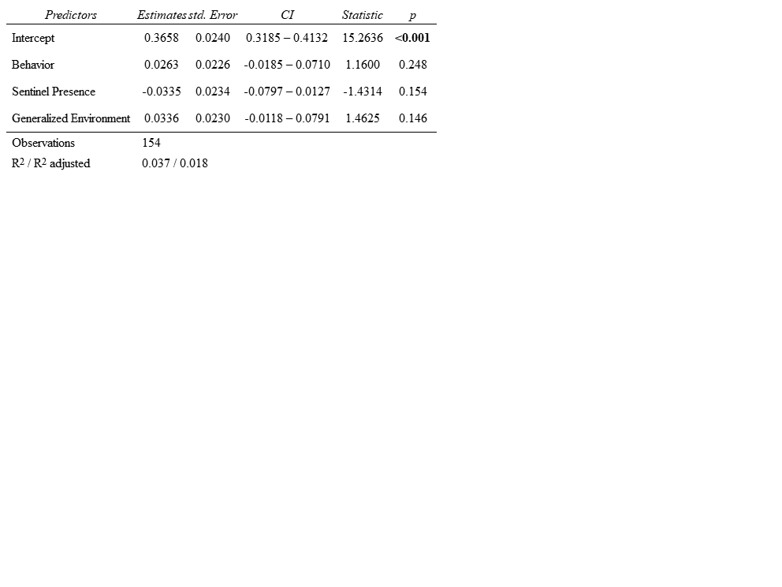

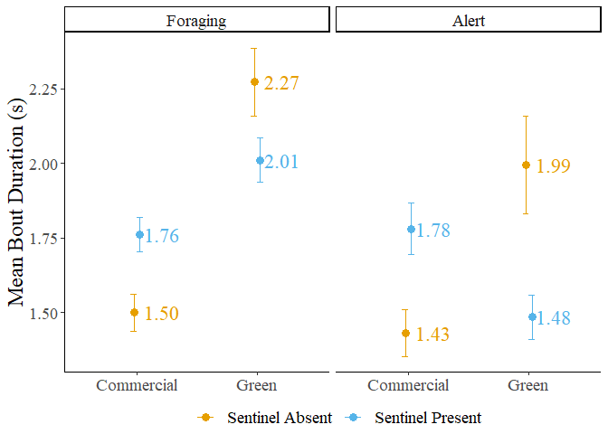

Figure 3: Mean bout duration of foragers in commercial and green areas. The error bars represent the standard error.

Table : Results of the linear mixed models fit to the mean bout duration

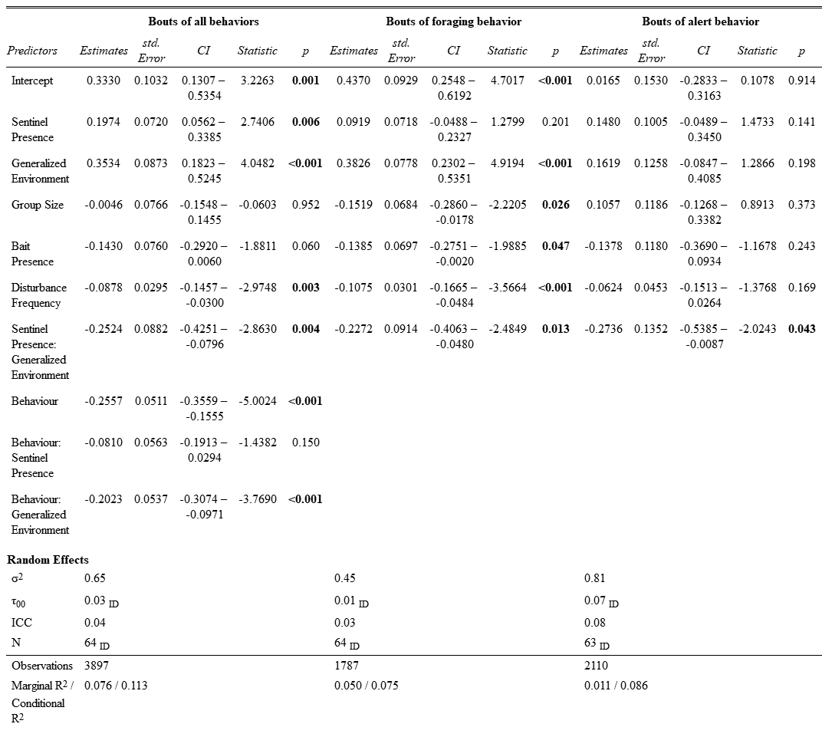

Duration of bouts of “foraging” behaviour

To determine if the generalized environment and sentinel presence affected the duration of bouts of foraging and alert behaviour differently, we fit separate linear mixed models for each type of behaviour bout. Sentinel presence had no significant effect on the duration of bouts of foraging behaviour ( $\hat{β}$ = 0.092, SE = 0.072, t = 1.280, p = 0.201; Figure 3, Table 2). Generalized environment had a significant effect on the duration of bouts of foraging behaviour, with longer bouts in green areas ( $\hat{β}$ = 0.383, SE = 0.078, t = 4.919, p = <0.001; Figure 3, Table 2). Larger groups had significantly longer bouts of foraging behaviour ( $\hat{β}$ = -0.152, SE = 0.068, t = -2.221, p = 0.026; Figure 4, Table 2). The presence of bait decreased the duration of foraging bouts ( $\hat{β}$ = -0.139, SE = 0.070, t = -1.989, p = 0.047; Figure S4, Table 2). Increasing disturbance frequency significantly decreased the duration of foraging bouts ( $\hat{β}$ = -0.108, SE = 0.030, t = -3.566, p = <0.001; Figure 5, Table 2). We found a significant interaction between generalized environment and sentinel presence ( $\hat{β}$ = -0.227, SE = 0.091, t = -2.485, p = 0.013; Figure 3, Table 2).

Post hoc tests revealed significant differences in the duration of bouts of foraging behaviour. In the absence of a sentinel, foragers in green areas had significantly longer bouts of foraging behaviour than in commercial areas ( $\hat{β}$ = -0.383, SE = 0.078, z-ratio = -4.919, p < 0.001; Table S3). In the presence of a sentinel, foragers in green areas also had significantly longer bouts of foraging behaviour than in commercial areas ( $\hat{β}$ = -0.156, SE = 0.067, z-ratio = -2.337, p = 0.029; Table S3). In green areas, foragers in the presence of a sentinel had marginally shorter bouts of foraging behaviour than in the absence of a sentinel ( $\hat{β}$ = 0.135, SE = 0.068, z-ratio = 1.977, p = 0.058; Table S3).

Duration of bouts of “alert” behaviour

Sentinel behaviour, generalized environment, group size, bait presence and disturbance frequency had no significant effect on the duration of bouts of alert behaviour (p < 0.141; Table 2). We found a significant interaction between sentinel behaviour and generalized environment ( $\hat{β}$ = -0.274, SE = 0.135, t = -2.024, p = 0.043; Figure 3, Table 2). Post hoc pairwise t-tests revealed no significant differences in the duration of bouts of alert behaviour.

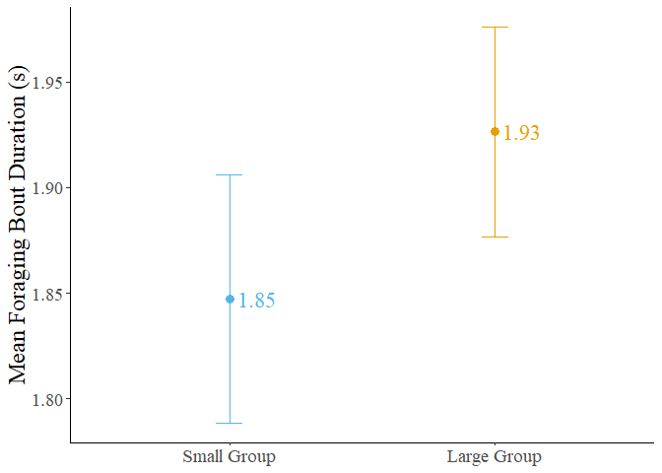

Figure 4: Mean foraging bout duration of crows in small and large groups. Error bars represent the standard error.

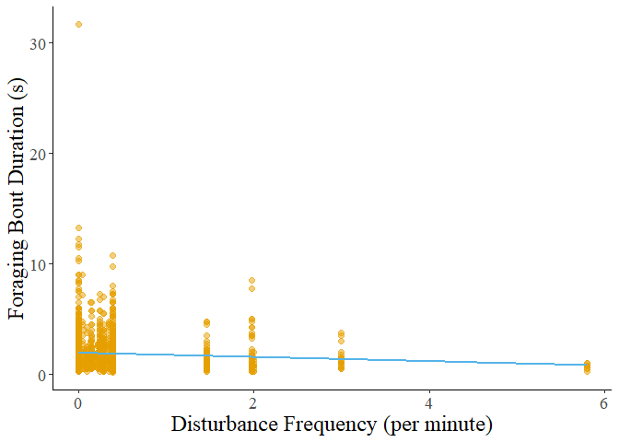

Figure : Foraging bout duration decreasing with increasing disturbance frequency.

Foraging rate

We calculated the peck rate (per min.) for 81 observations. Two observations were removed as the individuals did not perform any foraging behaviour. Neither the presence of a sentinel nor the generalized environment alone had a significant effect on the peck rate of foragers (p > 0.702; Figure 6, Table 3). The presence of bait significantly increased the peck rate of foragers ( $\hat{β}$ = 13.990, t = 2.231, p = 0.020; Figure S5, Table 3). Peck rate increased significantly with disturbance frequency ( $\hat{β}$ = 5.290, t = 2.312, p = 0.021; Figure 7, Table 3). We found a significant interaction between generalized environment and disturbance frequency ( $\hat{β}$ = 16.150, t = 3.046, p = 0.002; Figure 7, Table 3).

Transition analysis

Transitions from foraging to alert behaviour were significantly affected by generalized environment (IRR = 2.115, SE = 0.0.769, z = 2.062, p = 0.039; Figure 8, Table 4) and disturbance frequency (IRR = 0.728, SE = 0.109, z = -2.130, p = 0.033; Figure 9, Table 4). We found a significant interaction between generalized environment and sentinel presence (IRR = 0.199, SE = 0.098, z = -3.298, p = 0.001; Figure 8, Table 4). The presence of bait significantly increased the number of transitions from foraging to pecking (IRR = 1.710, SE = 0.384, z = 2.386, p = 0.017; Figure S6, Table 4). All other factors did not affect this transition (p-value > 0.436; Table 4). The presence of bait significantly increased the number of transitions from pecking to alert behaviour (IRR = 2.204, SE = 0.538, z = 3.238, p = 0.001; Figure S6, Table 4). All other factors did not affect this transition (p-value > 0.235; Table 4). Transitions from alert to foraging behaviour were not significantly affected by any factors, however, bait presence had a marginally insignificant effect (IRR = 1.513, SE = 0.351, z = 1.789, p = 0.074; Figure S6, Table 4).

Post hoc testing on the number of transitions from foraging to alert behaviour revealed that in green areas, individuals performed more transitions from foraging to alert when in the presence of a sentinel ( $\hat{β}$ = -1.124, SE = 0.346, z-ratio = -3.250, p = 0.007; Table S4). Foragers in the presence of a sentinel performed marginally more transitions from foraging to alert in green areas than in commercial areas ( $\hat{β}$ = -0.749, SE = 0.364, z-ratio = -2.062, p = 0.079; Table S4). However, foragers in the absence of a sentinel performed marginally more transitions from foraging to alert behaviour in commercial areas than in green areas ( $\hat{β}$ = 0.864, SE = 0.372, z-ratio = 2.321, p = 0.061; Table S4).

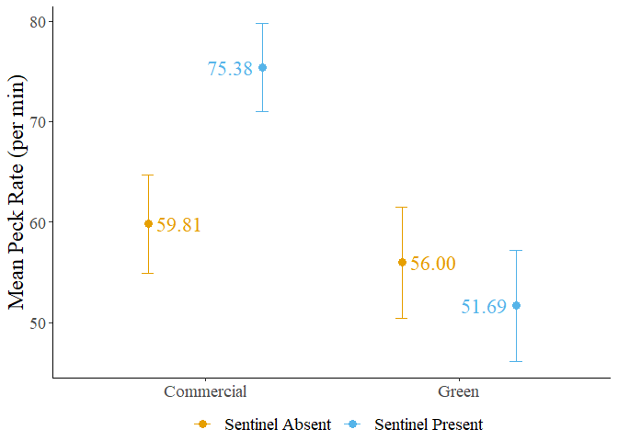

Figure 6: Mean peck rate of foragers in commercial and green areas. Error bars represent the standard error.

Table : Result of the linear mixed model fit to forager peck rate

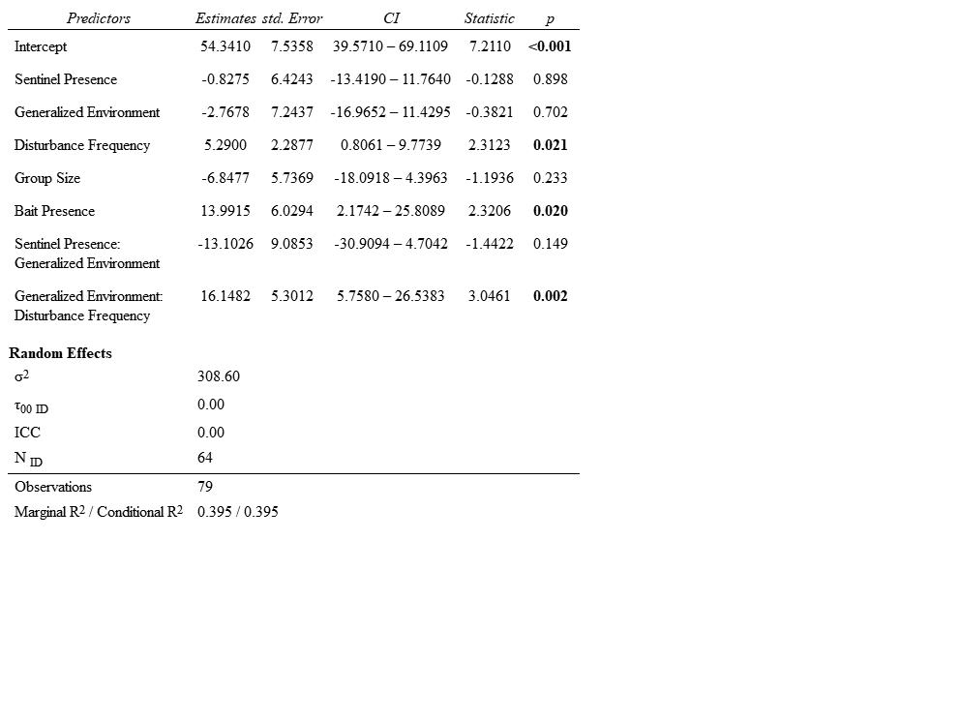

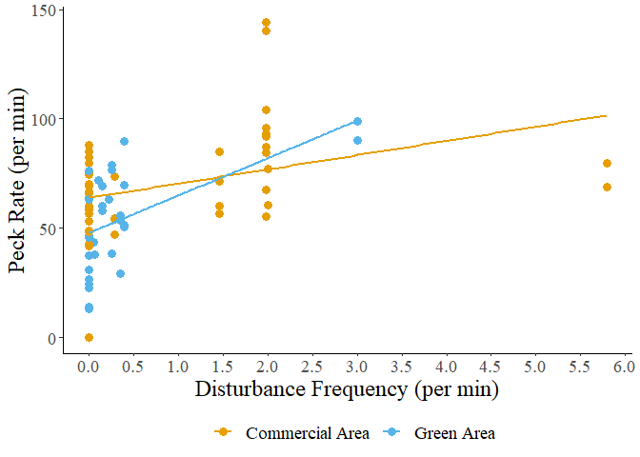

Figure : Peck rate of foragers in relation to disturbance frequency.

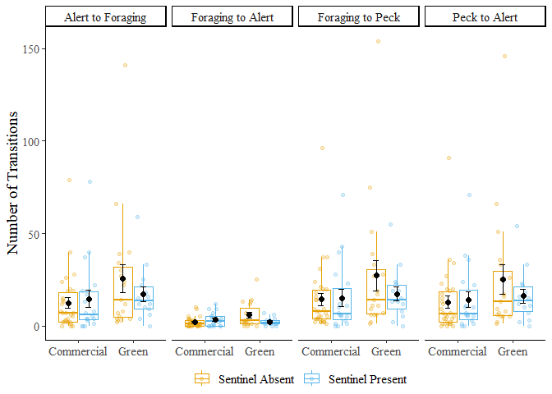

Figure 8: Number of transitions performed by foragers in commercial and green areas. Error bars represent the standard error.

Table : Results of generalized linear mixed model fit to the number of transitions performed by foragers

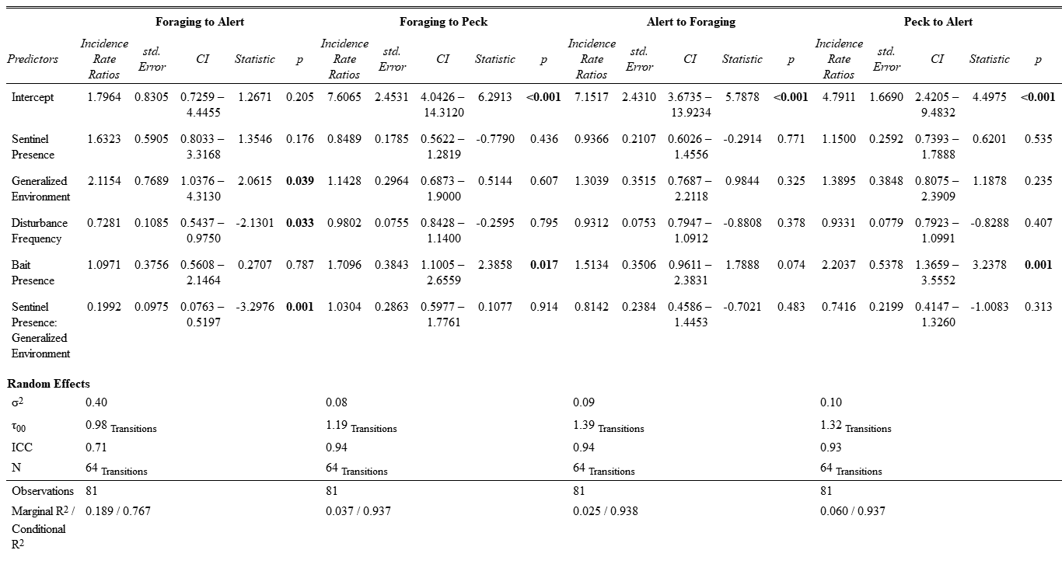

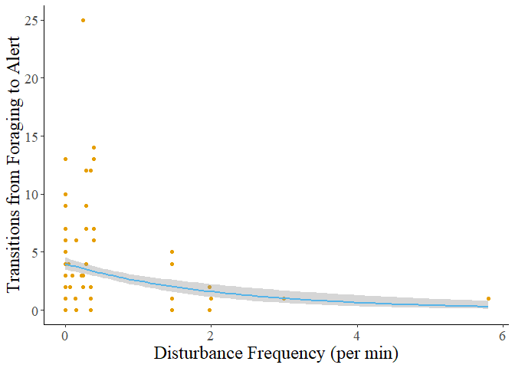

Figure : The number of transitions from foraging to alert behaviour decreases as disturbance frequency increases. The grey shadow represents the standard error of the curve.

References

1. Møller AP. 1990 Changes in the size of avian breeding territories in relation to the nesting cycle. *Anim. Behav.* **40**, 1070–1079. (doi:10.1016/S0003-3472(05)80173-3)

2. Friard O, Gamba M. 2016 BORIS: a free, versatile open-source event-logging software for video/audio coding and live observations. *Methods Ecol. Evol.* **7**, 1325–1330. (doi:10.1111/2041-210X.12584)

3. R Core Team. 2022 R: the R project for statistical computing.

4. Koller M. 2016 Robustlmm: an R package for robust estimation of linear mixed-effects models. *J. Stat. Softw.* **75**, 1–24. (doi:10.18637/jss.v075.i06)

5. Bates D, Mächler M, Bolker B, Walker S. 2015 Fitting linear mixed-effects models using lme4. *J. Stat. Softw.* **67**, 1–48. (doi:10.18637/jss.v067.i01)

6. Lenth RW. 2023 Emmeans: estimated marginal means, aka least-squares means.

Supplemental Material

List of Supplemental Tables

Table S1: Explanation of generalized environment 22

Table S2: Ethogram of behaviours analyzed during foraging events 23

Table S3: Results of post hoc tests on foraging bout duration 27

Table S4: Result of post hoc test performed on the number of transitions from foraging to alert behaviour 31

List of Supplemental Figures

Figure S1: Sentinel presence in commercial and green areas 24

Figure S2: Frequency plots of observations in the presence and absence of a sentinel 25

Figure S3: Decreasing bout duration of all behaviours in response to increasing disturbance frequency 26

Figure S4: Mean bout duration in the presence and absence of bait 28

Figure S5: Mean forager peck rate in the presence and absence of bait 29

Figure S6: Number of transitions performed by foragers in the presence and absence of bait 30

Table S: Explanation of generalized environment.

|  |  |
| --- | --- |
| Generalized Environment | Zones included |
| Commercial Area | Arterial Commercial, Business Commercial Employment, Community Commercial, Major Commercial |
| Green Area | Major Green Space, Minor Green Space |

Each zone type was identified using the St. Catharines and Niagara zoning maps for each sampling location.

Table S: Ethogram of behaviours analyzed during foraging events.

|  |  |  |  |
| --- | --- | --- | --- |
| Behaviour | Code | Definition | Illustration |
| Foraging | Head Down | Focal individual is stationary and has its head downwards or in a non-upright position, either pecking or handling food, looking for food, or engaging in other behaviours that make vigilance ineffective (e.g. preening). |  |
| Moving | Moving | Focal individual is moving, either by flying, hopping (leaping), or walking. |  |
| Alert | Head Up | The focal individual is stationary and has its head and body in an upright position. Individuals can have a mobile (scanning) or immobile head but must not be looking downwards. Individuals can be handling food. |  |

*All illustrations are under creative commons license (copyright-free)*

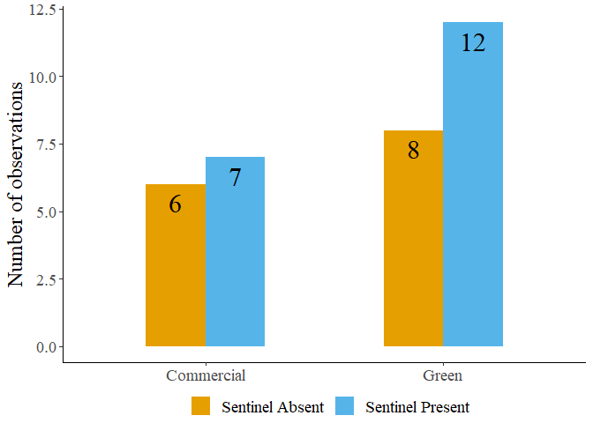

Figure S: Sentinel presence in commercial and green areas.

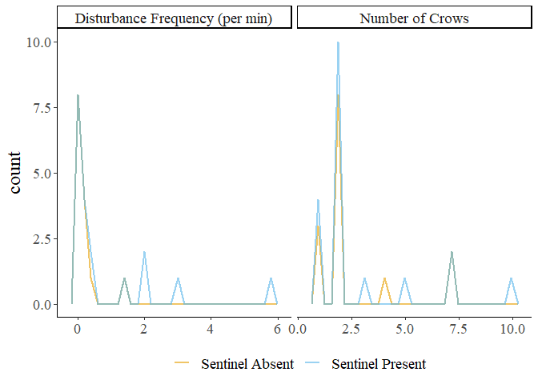

Figure S: Frequency plots of observations in the presence and absence of a sentinel.

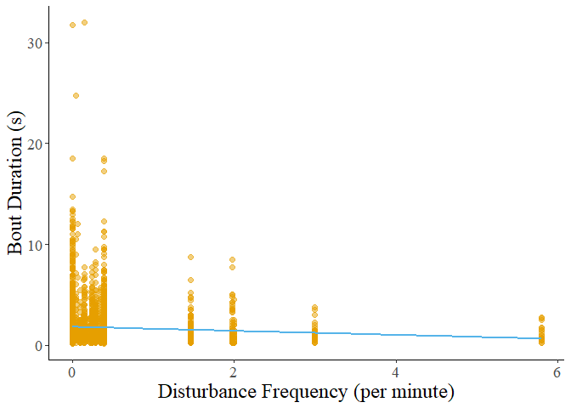

Figure S: Decreasing bout duration of all behaviours in response to increasing disturbance frequency.

Table S: Results of post hoc tests on foraging bout duration.

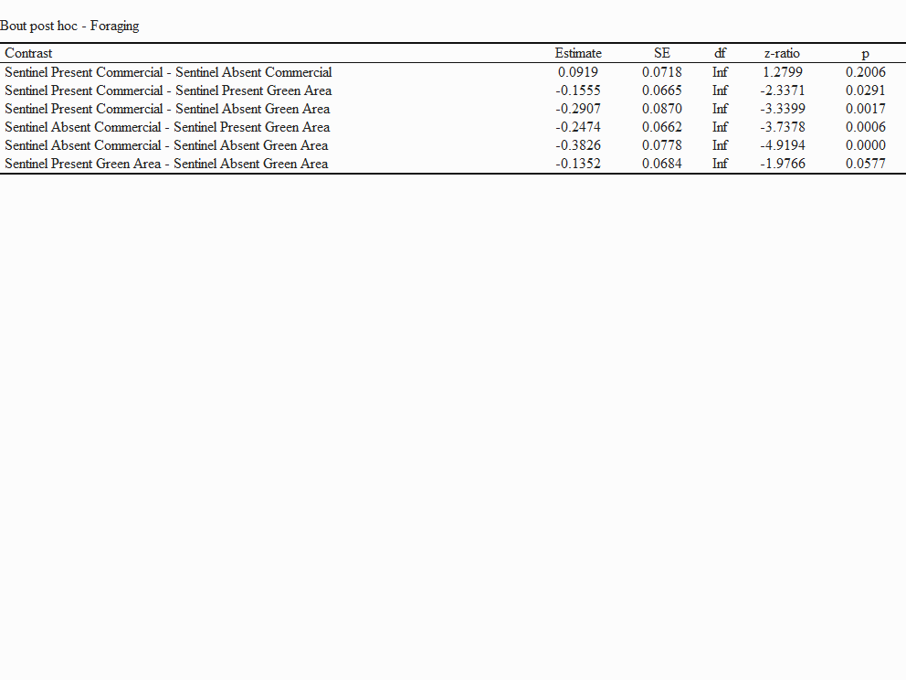

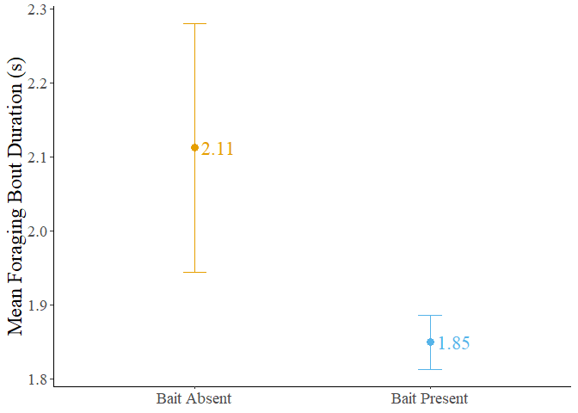

Figure S4: Mean bout duration in the presence and absence of bait. The dots represent the mean value, and the error bars represent the standard error.

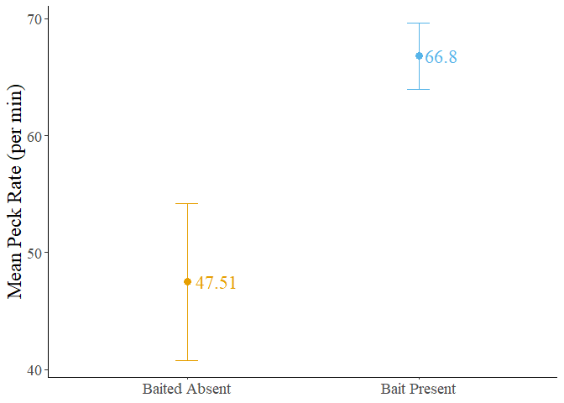

Figure S5: Mean forager peck rate in the presence and absence of bait. The dots represent the mean value, and the error bars represent the standard error.

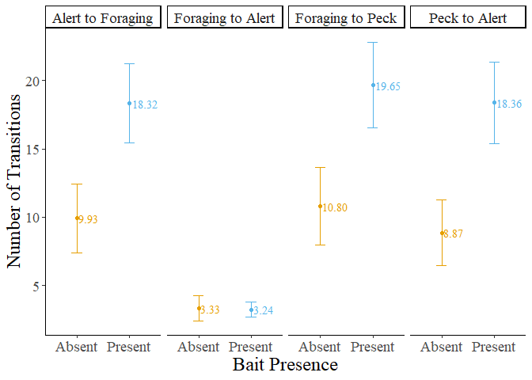

Figure S: Number of transitions performed by foragers in the presence and absence of bait. The dots represent the mean value, and the error bars represent the standard error.

Table S: Result of post hoc test performed on the number of transitions from foraging to alert behaviour.

